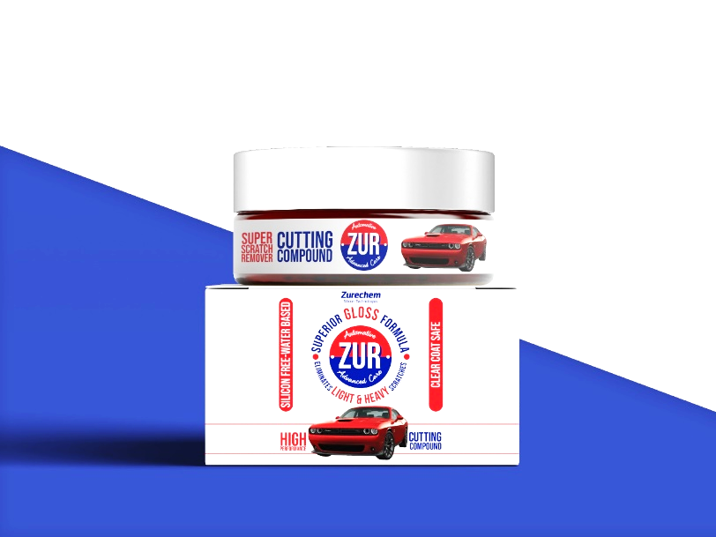

**Product Information**

* **Available packaging**

|  |  |
| --- | --- |
| Paste | liquid |
| 75 ml | **125 Ml** |
| 150 ml | **250 Ml** |
| 250 Ml | **1000 Ml** |
|  |  |

**Product description**

* **Polishing compounds delivers a mirror shine with durable protection, the advanced polish formulated using diminishing abrasive technology.**
* **High cutting performance easy to remove P2000 sanding marks.**
* **High gloss and low dust technology.**
* **High lubrication system with longer polishing time.**
* **Low consumption and time saving formula.**
* **No aggressive smell & Easy to be wiped off.**

**Cutting range**

**ml ml**

**ml ml**

**ml ml**

**ml ml**

**ml ml**

**ml ml**

**Gloss range**

**Key benefits**

* **Reliable Cut Removes P2000 or finer abrasive marks quickly and easily.**
* **Permanent finish contains no fillers so scratch marks won’t re-appear.**
* **High gloss system Excellent gloss .**
* **Silicone free 100% paintshop safe**



**Machine Application**

**1**

**3**

**4**

**5**

ATTACH

1500 - 1800rpm

**Soak the compounding foam in water.**

**Attach the pad to the polishing machine spin off the excess water.**

**Spread at 1000 rpm and compound at 1500 - 1800rpm with light pressure Apply more water if necessary.**

**Wipe clean with Finishing Cloth.**

**Hand Application**

**1**

**2**

**3**

**4**

**Soak the hand compounding foam or the microfiber cloth in water.**

**Rub the product on the surface in back and forth motion**

**Apply water if necessary. Wipe clean with microfiber cloth.**

**How To Use**

**Shake or mix the compound well , then apply to the pad or surface.**

**Shake or mix the compound well , then apply to microfiber cloth or surface.**